

**SOFTWARE TESTING**

**CALCULATE TLH PROJECT**

**Version:** 1.0

**Date:** Oct 5th, 2017

**PROJECT TEAM :** GROUP 9

**MENTOR :** PHAM THI LE TRINH

**TEAM'S MEMBER :** NGO QUANG TRUNG

TRAN NGOC HAY

DOAN DIEP LINH

**INTERNATIONAL SCHOOL OF DUY TAN UNIVERS**

Table of Contents

**1.** **Introduction** 3

**1.1.** **Purpose** 3

**1.2.** **Scope** 3

**2.** **Product Perspective** 3

**3. Use cases diagram** 4

**4. Context diagram** 4

**5. Use cases detail** 5

**5.1.** **Use case basic calculate** 5

**5.2. Use case Solve Linear Equation** 5

**5.3. Use case Solve Quadratic** **Equation** 6

1. **Introduction**
   1. **Purpose**

* Purpose of this document is to describe requirement specifications for Calculator TLH to inform of the significant details and background of our project. This project is simulating the basic algebraic.The basic algebraic functions will include addition, subtraction, division, and multiplication.
  1. **Scope:**
* This document specifies the functional requirements for a multi-function calculator program. The program is designed to act like a “handheld calculator” with the usual standard functions (add, subtract, multiply, divide, exponentiation). The program is designed to be as easy to use as a regular calculator.

1. **Product Perspective**

* Caculator TLH shall be implemented in Visual Basic. Thefeatures provided by the calculator include all features typical of a calculator. Enter numbers either by click use the on-screen keyboard. To use thearithmetic functions, click their buttons.

1. **Use cases diagram**

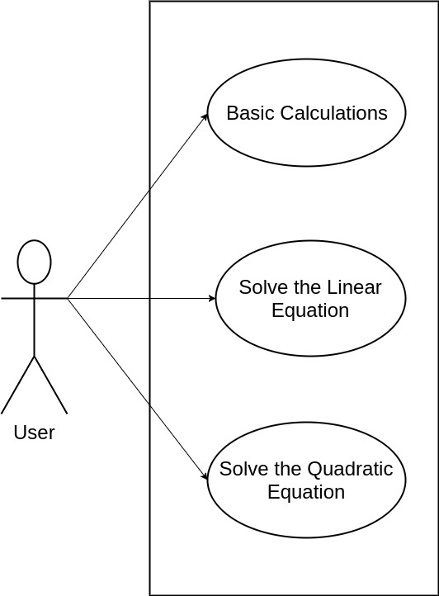

## *Figure: Use case diagram of user*

1. **Context diagram**

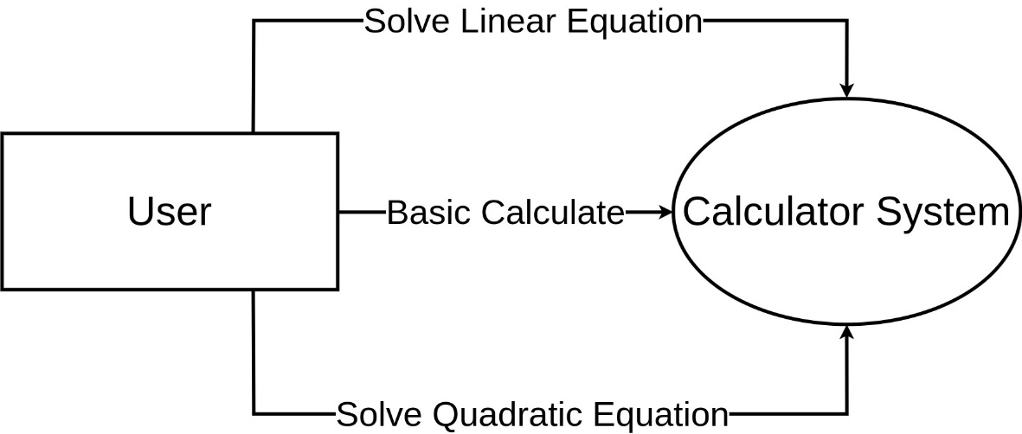

*Figure: Use case diagram of context diagram*

1. **Use case detail**
   1. **Use case basic calculate**

|  |  |  |  |
| --- | --- | --- | --- |
| *ID* | **UC1** | *Use case name* | **Basic calculate** |
| *Author* | **User** | *Updater* |  |
| **Describe** | * User calculates basic operations such as addition, subtraction, multiplication, division, square root, and exponentiation. | | |
| **Actor** | User | | |
| **Scenario** | - Step 1: Open system.  - Step 2: Choose number.  - Step 3: Choose calculation.  - Step 4: Choose number.  - Step 5: Choose “=” button. | | |

* 1. **Use case Solve Linear Equation**

|  |  |  |  |
| --- | --- | --- | --- |
| *ID* | **UC1** | *Use case name* | **Solve linear equation.** |
| *Author* | **User** | *Updater* |  |
| **Describe** | * Users who want to solve the solve linear equation use this function. | | |
| **Actor** | User | | |
| **Scenario** | - Step 1: Open system.  - Step 2: Choose “Giải phương trình” button.  - Step 3: Choose “Bậc 1” button.  - Step 4: Input number.  - Step 5: Choose “Giải” button. | | |

* 1. **Use case Solve Quadratic Equation**

|  |  |  |  |
| --- | --- | --- | --- |
| *ID* | **UC1** | *Use case name* | **Solve quadratic equation.** |
| *Author* | **User** | *Updater* |  |
| **Describe** | * Users who want to solve the solve quadraticequation use this function. | | |
| **Actor** | User | | |
| **Scenario** | - Step 1: Open system.  - Step 2: Choose “Giải phương trình” button.  - Step 3: Choose “Bậc 2” button.  - Step 4: Input number.  - Step 5: Choose “Giải” button. | | |